Strategic Compositional Engineering in Quasi-2D Ruddlesden-Popper Perovskites to Decipher Deep Blue Emission
Ranadeep Raj Sumukam¹, Gundam Sandeep Kumar¹, Ramu Naidu Savu, and Banavoth Murali*
Solar Cells and Photonics Research Laboratory, School of Chemistry, University of Hyderabad, Prof. C R Rao Road, Hyderabad -500046, Telangana State, India.
*Email: murali.banavoth@uohyd.ac.in

Abstract
Perovskites have achieved immense progression in optoelectronic device applications owing to their fascinating intrinsic properties. However, the integration of perovskites in lighting applications has been retarded due to the challenges involved in achieving their deep blue light-emitting diodes (LEDs). Unlike other color counterparts, obtaining a stable, defect-tolerant, and high bandgap perovskite material for deep blue emission is an arduous task. Moreover, the ambient stability and efficient charge injection in the device are the bottlenecks for the established perovskite emissive materials. Among all the dimensional perovskite counterparts, quasi-two-dimensional perovskites (Q2DPes) with hydrophobic ligands can exhibit better stability and also facilities facile tunability of the properties can overcome the associated challenges. In this paper, for the first time, we demonstrated Ruddlesden-Popper-based Q2DPes that are pure deep blue emissive in the 450 nm region, which are stable and can facilitate decent charge injection in the LEDs. We have also demonstrated systematic modulations in the properties of the material concerning the organic cation concentration.

3.1 Introduction
Perovskite materials have received accolades in recent times owing to their alluring properties that bestow potential to use in photovoltaic and optoelectronic applications.¹⁻⁵ The key attributes are high absorption coefficients, high photoluminescence quantum yield (PLQY), defect tolerance, and long carrier diffusion length.⁶⁻⁹ In addition, pure color emissions, ease of color tuning properties by controlling dimensionality and composition, and facile solution-based synthesis methods have fostered perovskites in light-emitting diode (LED) applications. Perovskites have achieved the external quantum efficiency (EQE) of over 20% in near-infrared, red, and green LEDs owing to significant progress over years in compositional engineering, structural engineering, minimizing surface defects, and tailoring their microstructures.¹⁰⁻¹³ However, the advancement of perovskites in display technology and white-light illumination has been hampered because of the impediments to achieving deep blue LEDs. In addition, the ubiquitous instability of perovskites against moisture is detrimental to the future projection of the perovskite material’s market. Therefore, deep and pure blue emissive perovskites with enhanced stability are the pressing priority in the realm of perovskite optoelectronics.
In general, there is a requirement for higher working voltages for deep blue emission, thus, all-inorganic perovskites are preferred over hybrid organic-inorganic perovskites as they exhibit higher stability.¹⁴⁻¹⁵ To date, for blue emission, extensive work has been conducted on CsPbX₃ (X= Br¯ or Cl¯ or Br¯/Cl¯) nanocrystals.¹⁶⁻¹⁸ For the first time in 2015, Song et al. demonstrated blue emissive CsPb(Br/Cl)₃ nanocrystals that can be tuned in 420-585 nm range.¹⁹ However, significant non-radiative recombination channels and inefficient charge injection due to long insulating ligands have severely affected the performance of nanocrystal-based perovskite LEDs (PeLEDs). Thereafter, various approaches have been explored to enhance the performance of PeLEDs, nevertheless, the insulating passivation on the perovskite nanocrystals limited the overall performance of the PeLEDs. Meanwhile, blue emissive two-dimensional (2D) perovskite nanoplates with inherent exciton quantum confinement have also displayed high PLQYs, but their PeLEDs EQEs are less than 1% due to inefficient charge injection.²⁰⁻²⁵ Considering the challenges associated with zero-dimensional nanocrystals and two-dimensional nanoplates, in this paper, we tried to provide a solution for the mentioned issues using quasi-two-dimensional perovskites (Q2DPes) as they are intrinsically stable against moisture to some extent and allow facile dimensional and compositional engineering.²⁶⁻²⁷ To the best of our knowledge, this is the first report demonstrating tuning of the Q2DPes emission towards the desired deep blue region around 450 nm, which is crucial for practical lighting applications.
Q2DPes have a general formula Aʹ₂(APbX₃)_{n-1}PbX₄ where Aʹ= primary aliphatic or aromatic alkylammonium organic cation, A= organic/inorganic cation, X= Br, Cl, and n= number of perovskite layers in inorganic framework.²⁶⁻²⁷ They are formed by incorporating subsequent organic cations interlayer in the 3D inorganic framework as shown in Figure 3.1a. Each unit of the perovskite framework is kept intact with another and maintains structural integrity by the synergistic interaction of both coulombic and hydrophobic forces. The Q2DPes are natural multiple-quantum well-like structures where the inorganic semiconducting framework act as potential wells and organic insulating layers act as potential barriers as shown in Figure 3.1b.²⁸⁻²⁹ Herein, the Q2DPes quantum wells manifest n (number of perovskite layers in the inorganic framework) dependent dielectric and quantum confinement effects as the result of conductivity difference between organic and inorganic frameworks and reduced dimensionality, respectively. These confinement effects eventually facilitate the hypsochromic shift in emission, high exciton binding energy, and the Bohr radius that reaches out past the limits of a single layer of the Q2DPe material.³⁰ In comparison to classical semiconductor-based quantum wells, Q2DPes offer colossal benefits in view of the tunability of their optoelectronic properties through both quantum mechanical and compositional parameters.
Figure 3.1: Schematic illustration of (a) layered structures of RP type Q2DPe with different phases from n = 3 to n = 1. (b) Quantum well structure of Q2DPes where perovskite inorganic framework sandwiched between the barriers of organic ammonium-based spacer ligands. (c) Energy diagram of the [PbX₆]¯ units wherein atomic levels move in the direction of the arrows when the high electronegative halide has been introduced in the lattice.
3.2 Results and Discussion
In the present work, we have chosen Ruddlesden-Popper (RP) type phenylethylamine (PEA) based Q2DPe (PEA)₂Cs_{n-1}Pb_{n}(Br_{x}Cl_{x-1})_{3n+1} to achieve deep blue emission via compositional and structural engineering. In addition, we demonstrated the impact of organic cation and halide anion concentrations on material properties. Initially, we have optimized the composition of the parent CsPbBr₃ perovskite system’s framework to blue shift the emission to the highest possible extent. Because, though the quantum confinement effect in Q2DPes could undoubtedly blue shift the emission, but the inevitable multiple phases (with different n) in Q2DPe-based LEDs deteriorate the high energy blue emission and only green emission shows up.³¹⁻³² This attributes to the exceptionally proficient energy/exciton transfer/funnelling from the higher bandgap perovskite phase (lower ‘n’ phase) to the lower one (higher ‘n’ phase).³³ To circumvent this obstruction, along with dimensionality tuning, halide site compositional engineering is the best suitable approach to increase the bandgap of the highest n phase (lowest bandgap) in Q2DPe thin film. In the perovskites, X-sites of the lattices confer a significant impact on ionization energy, electron affinity, carrier dynamics, and stability that governs the optoelectronic properties of the system.³⁴⁻⁴⁰ The replacement of Br¯ with Cl¯ in the perovskite lattice fosters raise in the bandgap. This is due to the downshift of the valency band maximum (increase in ionization energy) as a consequence of the strong downward shift of the higher electronegative halide’s p atomic level, which determines the valency band maximum of the perovskite. On the other side, the atomic level p of Pb which determines the conduction band minimum (electron affinity) undergoes an upward shift while going from Br¯ (bigger) to Cl¯ (smaller) due to the confinement effect caused by the decrease in Pb-X distances. Therefore, both the electronegativity effect and confinement effect of halides eventually promote an increase in the bandgap as shown in Figure 3.1c. It is worth mentioning other weaker factors that oppose the widening of the bandgap are an increment in hybridization strength of Pb’s s and halide’s p levels and upward shift of s level of Pb as a result of confinement mentioned above by replacing Br¯ with Cl¯.⁴¹⁻⁴⁴ Herein, initially, we have optimized the composition of the parent CsPbBr₃ perovskite system’s framework by partially replacing Br¯ with high electronegative anion Cl¯ to blue shift the emission to the highest possible extent. It is worth mentioning that an increase in Cl¯ concentration beyond a certain limit in the perovskite precursor leads to precipitation due to the reduction in solubility. Then we systematically introduced phenylethylammonium chloride (PEACl) salt into CsPb(Br/Cl)₃ parent system to obtain blue emissive (PEA)₂Cs_{n-1}Pb_{n}(Br_{x}Cl_{x-1})_{3n+1} Q2DPe thin films. Then we studied the role of PEACl on the optoelectronic, structural and morphological characteristics of the perovskite material.
We used CsBr, PbBr₂, and PbCl₂ to synthesize CsPbBr_{x}Cl_{1-x} perovskite, wherein we strategically incorporated optimum PbCl₂ by partially replacing PbBr₂ in the perovskite precursor. Finally, we have synthesized an optimized composition CsPbBr_{1.8}Cl_{1.2,} emissive in the blue region peaking at 477.5 nm with a maximum fraction of PbCl₂ in the precursor (PbBr₂ : CsBr : PbCl₂ is 2 : 5 : 3) without exceeding the solubility limit. In addition, we introduced yttrium(III) chloride (YCl₃) (2% with respect to CsBr) as an additive or surface passivation agent, as it can confine the charge carriers to promote radiative recombination by increasing the bandgap of the perovskite’s grain shell.⁴⁵ Thereafter, by considering the CsPbBr_{1.8}Cl_{1.2} system to synthesize RP type Q2DPes for deep blue emission we introduce PEACl in the precursor. We have chosen PEACl for synthesis because, in comparison to other bulk organic cations, PEA⁺ has a significantly high triplet state energy level and decent binding energy which reduces the triplet quenching losses and forms a strong interaction with the inorganic octahedra of the perovskite framework that enhances the stability, respectively.⁴⁶⁻⁴⁷ Herein, we deliberately increased the PEACl concentration from 0% to 140% (with respect to CsBr) and studied the effect of PEACl on the optoelectronic properties of the perovskite materials (Refer supporting information for the synthesis procedure). As shown in the Figure 3.2a, with the increase in PEACl concentration from 0%to 30% the absorption peak of the 3D phase has been shifted towards the lower wavelength region, in addition, the formation of n=3, n=2, and n=1 phases were noticed, which indicates the reduction in 3D phase and inception of quasi 2D phases. Further increase in the PEACl to 60%, 80%, 100%, 120%, and 140% resulted in a gradual decrease in peak corresponding to 3D characteristics and increase in the 2D characteristics of the perovskite material. Moreover, for every subsequent higher concentration of PEACl in the precursor, we observed the blue shift in absorption peaks corresponding to different phases that ascribes to the incorporation of more Cl¯ ions in the inorganic framework of perovskite with increased PEACl concentration in the precursor. It is worth mentioning that beyond 100% PEACl the absorption peak corresponding to n=1 and n=3 gradually decreased. Finally, at 140% PEACl, no absorption peak was observed for the n=1 phase indicating no traces or very negligible concentration of that phase in the thin film, and broad absorption peaks were obtained for n=2 and 3 phases that may be due to the inhomogeneous halide concentration in the inorganic framework of the Q2DPe (Confirmed with PL).
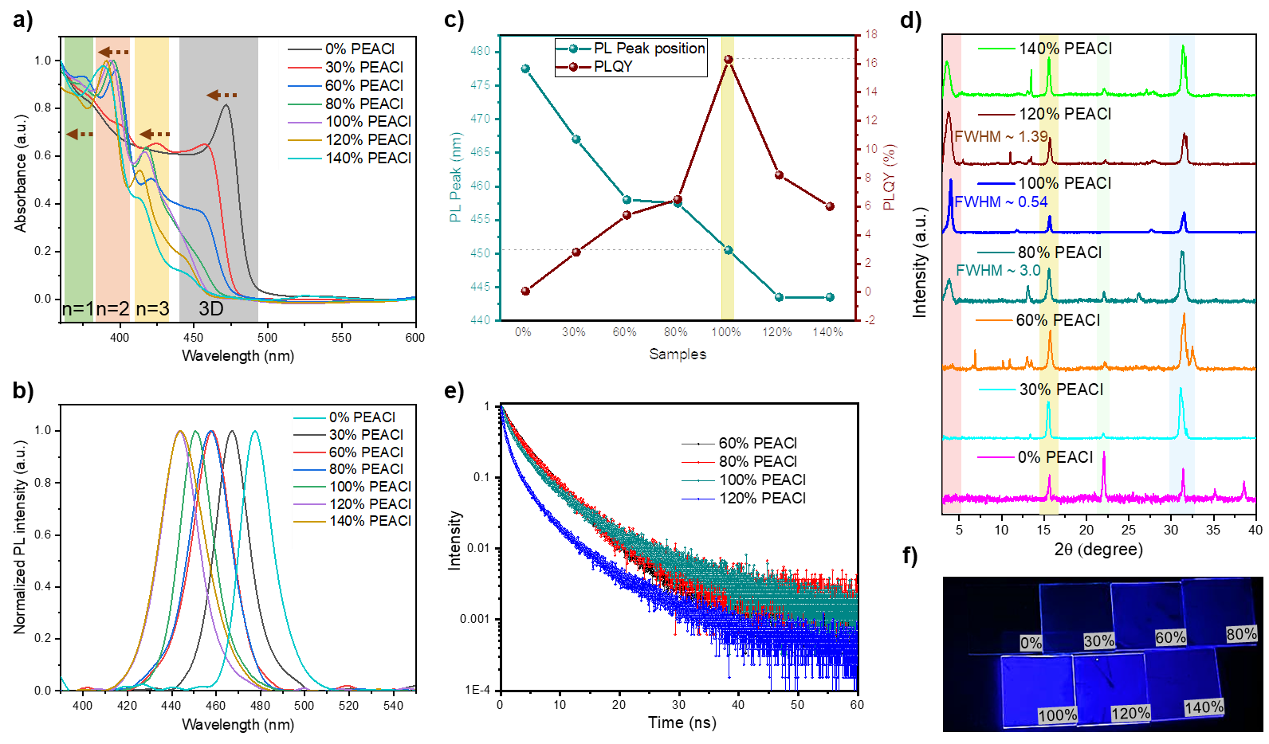
Figure 3.2: Formation of Q2DPes (PEA)₂(Cs)_{n-1}Pb_{n}(Br_{x}Cl_{1-x})_{3n+1} from CsPbBr_{1.8}Cl_{1.2} by PEACl incorporation. a) UV-Vis absorption spectra of the thin films. b) PL emission spectra of thin films. c) Graph showing the trend in PL peak positions and PLQYs of the samples. d) Powder XRD spectra of the thin films on glass. e) Time-resolved PL of the 60% PEACl - 120% PEACl thin films. f) Q2DPe thin films under UV light.

To investigate the emission properties of the Q2DPe thin films, we conducted photoluminescence (PL) studies. In accordance with absorption spectra, introduction of PEACl into the CsPbBr_{1.8}Cl_{1.2} system blue-shifted the emission peaks. The PL peaks of 0%, 30%, 60%, 80%, 100%, and 120% PEACl are 477.5 nm, 467 nm, 458 nm, 457.5 nm, 450.5 nm, and 443.5, respectively as shown in Figure 3.2b with full width half maximum (FWHM) of ~18nm. The thin films have exhibited gradual enhancement in PLQYs from ~0.075% to ~16.3% upon the addition of PEACl from 0% to 100%. There are two factors responsible for the enhancement of PLQY when we changed the PEACl concentration from 0% to 100%, one is due to the transition from 3D to Q2DPe upon the increase in PEACl which results in higher exciton binding energy and the other is due to effective surface passivation by the PEA⁺ and Cl¯ that reduce trap-assisted recombination.⁴⁸ However, beyond 100% PEACl, a gradual drop in PLQYs was noticed for 120% (8.2% PLQY) and 140% (~6.0% PLQY) PEACl compositions. The drop in PLQYs can be due to the reduced crystallinity of the material as the excess PEACl will increase the concentration of Cl¯ ions in the precursor which further reduces the solubility of the precursor solute and drives the crystallization faster. From Figure 3.2c we can observe a proper trend in the emission peaks and the PLQYs of the samples. In the case of 140% PEACl composition, no peak shift was observed with respect to 120% PEACl and we noticed PL peak broadening (FWHM=25 nm) that confirms inhomogeneous halide concentration in the inorganic framework of Q2DPe, which we have stated above with absorption spectrum. In table 3.1 we summarised the composition, emission peaks wavelengths, and PLQYs of all the samples.
Finally, for all the compositions of PEACl (0%, 30%, 60%, 80%, 100%, 120%, and 140%) in the CsPbBr_{1.8}Cl_{1.2} system, we observed only a single emission peak unlike the similar study reported before.³² These single PL peak emissions demonstrate an efficient exciton funnelling in these films from the lower n phase to the higher n phase. To confirm the fast exciton funnelling in the thin films, we excited the 100% PEACl composition thin film at three wavelengths corresponding to the UV-Vis absorption peaks at 372 nm, 393 nm, and 416 nm. We observed that the emission peak position is unchanged under the excitation of 372 nm and 393 nm as shown in Appendices II Figure 1 and no noticeable emission was observed at 416 nm. Further, structural characterization was done to confirm the crystallinity trend with PEACl concentration as stated above.
Table 3.1: Summary of the composition of the Q2DPe samples and their corresponding PL peaks and PLQYs  Sample name | CsBr | PbBr₂ | PbCl₂ | YCl₃ | PEACl | PLPeak(nm) | PLQY (%)
0% PEACl  30% PEACl  60% PEACl  80% PEACl  100% PEACl  120% PEACl  140% PEACl | 0.5  0.5  0.5  0.5  0.5  0.5  0.5 | 0.2  0.2  0.2  0.2  0.2  0.2  0.2 | 0.3  0.3  0.3  0.3  0.3  0.3  0.3 | 0.1  0.1  0.1  0.1  0.1  0.1  0.1 | 0.0  0.15  0.3  0.4  0.5  0.6  0.7 | 477.5  467  458  457.5  450.5  443.5  443.5 | 0.075  2.8  5.4  6.5  16.3  8.2  6.0
The ratio of the precursors is mole ratio

For structural investigation, X-Ray diffraction studies were conducted on Q2DPe thin films coated on glass substrates. In XRD spectra of thin films (Figure 3.2d), we observed a peak around 15.6º corresponding to the orthorhombic 3D perovskite phase and a peak around 4º corresponding to the 2D phase of the perovskite. The increase in PEACl concentration up to 100% resulted in gradual enhancement and narrowing of the diffraction peak around 4º where full width half maximum is ~0.54, which is less than any of its counterparts, indicates the improved crystallinity of the 2D phase of the thin film. Beyond the 100% PEACl, broadening of the peak around 4º was observed which clearly illustrates the reduced crystallinity of the perovskite when we added excess PEACl such as 120% and 140%.
We further confirmed the role of PEACl as a passivator through Time-resolved PL (TRPL) spectroscopic studies. Herein, we carried out TRPL studies for 60%, 80%, 100%, and 120% PEACl compositions, and the decay curves were fitted by the biexponential decay model as shown in the figure 3.2e. Therefore, the decay lifetime of these Q2DPe thin films consists of two lifetime components that are τ₁ and τ₂ corresponding to nonradiative monomolecular recombination and bimolecular radiative recombination, respectively. The average lifetime of the materials is given by Equation 3.1 where $τ_{avg}$ is average PL lifetime, $a_{i}$ is the amplitude of the i_{th} lifetime component and $τ_{i}$ is the lifetime of the i_{th} component.
$τ_{avg}={\sum_{i=1}^{2}{(a_{i}τ_{i}^{2})}}/{\sum_{i=1}^{2}{{(a}_{i}τ_{i})}}$ ̶ Equation 3.1
With the sequential increase of the PEACl concentration, the average PL lifetime (τ_{avg}) is in line with the PLQY trend. The τ_{avg} for 60%, 80%, 100%, and 120% PEACl compositions are found to be 4.11 ns, 4.49 ns, 5.43 ns, and 3.65 ns, respectively. The Q2DPe thin films under UV light shown in Figure 3.2f present an explicit governing of the PEACl on the optical properties of the material. Considering the above mention insights, we have illustrated the implications of introducing PEACl into the 3D perovskite system in Figure 3.3.
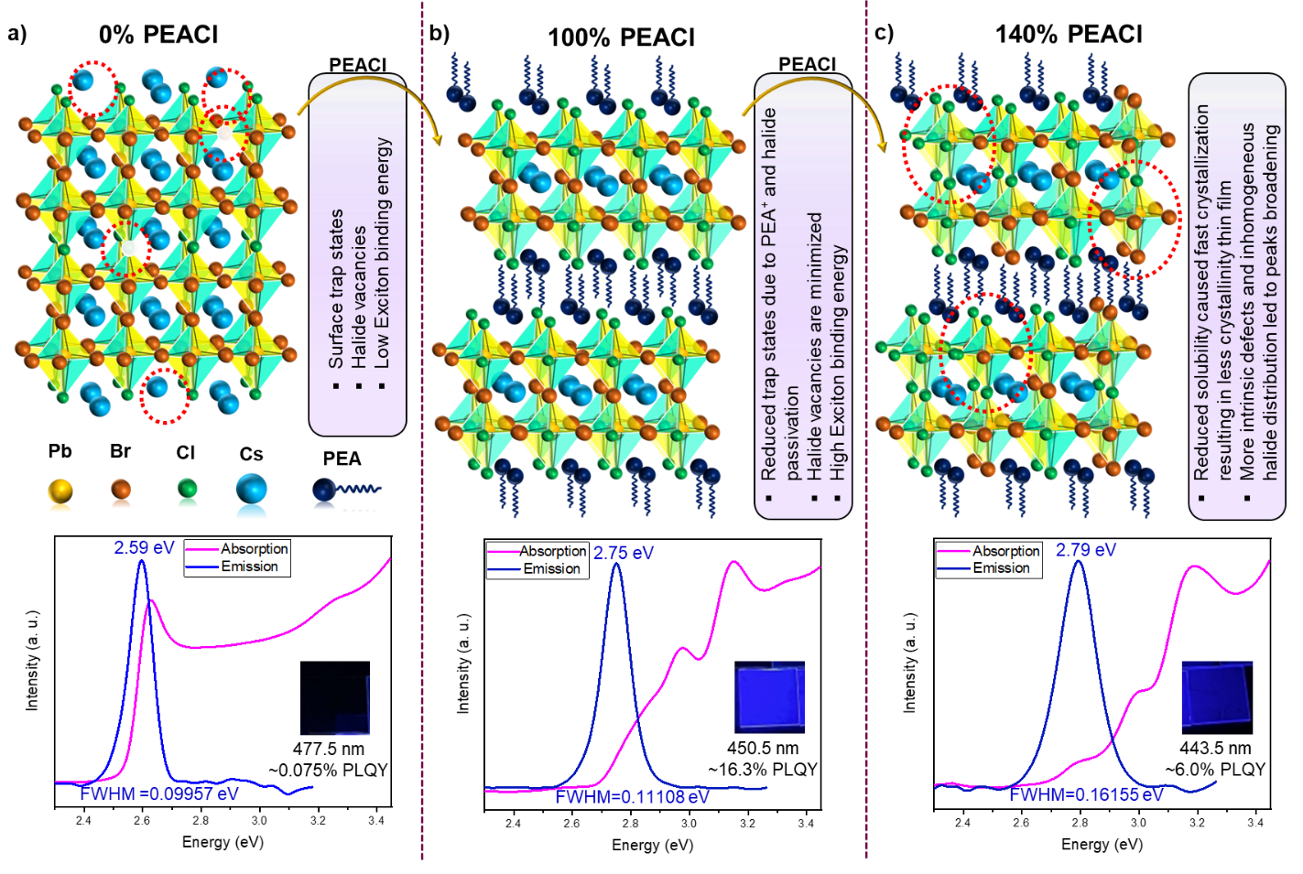
Figure 3.3: Schematic illustration of the implication of introducing PEACl into the 3D CsPbBr_{1.8}Cl_{1.2} system.
The morphology of this RP type Q2DPe was investigated by using Scanning Electron Microscopy (SEM) (Appendices II Figure 2) and Atomic Force Microscopy (AFM) (Figure 3.4), here also, the proper grain formation and high film coverage were in the same trend as mentioned above. In 0% PEACl composition, though the grain formation is fairly good the film coverage is poor. As the PEACl concentration increased film coverage has been improved but poor grain formation was observed. Considering both grain quality and film formation, 100% PEACl was the optimum composition where it exhibited decent grains and film coverage. Further increase in PEACl concentration over 100% resulted in poor grain formation and film coverage. Therefore, considering all the outcomes mentioned above, we conclude that 100% PEACl composition is the best performer. Wherein, it exhibited PL emission in the deep blue region at 450.5 nm with efficient PLQY among all.
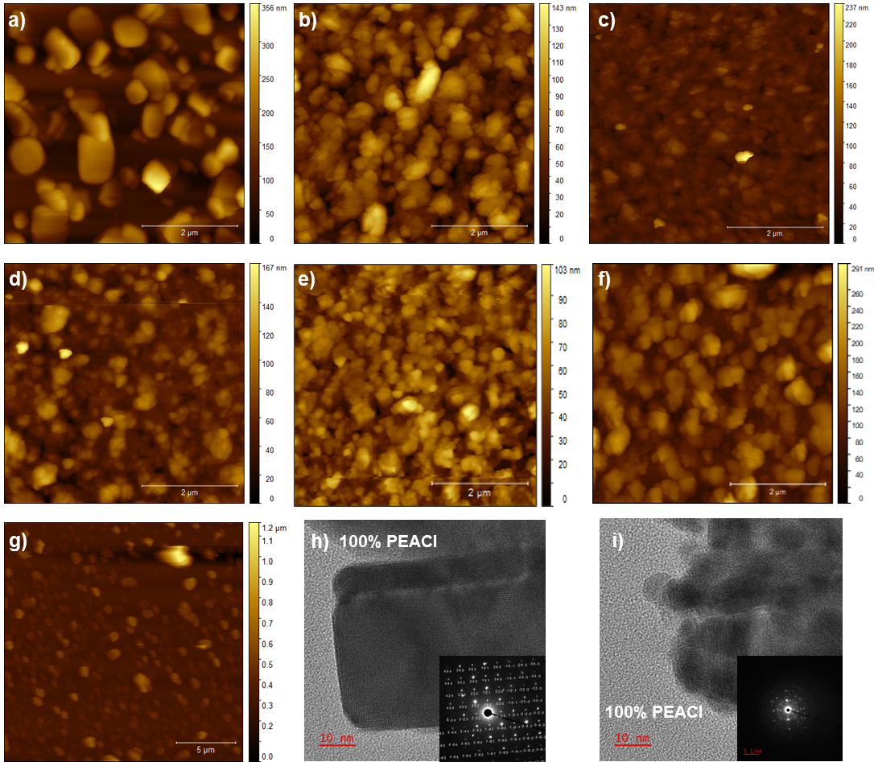
Figure 3.4. AFM micrograms showing the morphological changes in the thin films with the incorporation of PEACl into the 3D CsPbBr_{1.8}Cl_{1.2} system for a) 0% PEACl. b) 30% PEACl. c) 60% PEACl. d) 80% PEACl. e) 100% PEACl. f) 120% PEACl. g) 140% PEACl. h) TEM image of 100% PEACl composition at initial electron beam irradiation with SAED pattern in the inset. i) TEM image of 100% PEACl composition after irradiation with the electron beam for some time with SAED pattern in the inset.
To further illustrate the crystalline nature of the 100% PEACl we conducted Transmission Electron Microscope (TEM) characterization. As shown in Figure 3.4h SAED pattern confirms the high crystalline nature of the 100% PEACl composition perovskites. Herein, we observed that continuous irradiation by the high voltage electron gun resulted in the slow formation of domains in the homogeneous area of the film, where the direction of fringes in one domain is random to that of another (Appendices II Figure 3). Due to the formation of multiple domains, the same area which exhibited patterned spots in SAED indicating high crystalline nature demonstrated concentric circles which depict polycrystalline nature of the material (Figure 3.4i). This formation of domains in the films upon irradiation may be due to the phase segregation because of the initiation of ion migration with provided energy. Therefore, temperature-dependent studies were conducted to get insight into the mechanism.
Though the as prepared Q2DPes using the effective compositional engineering strategy exhibited high spectral stability under illumination, in order to confirm the phase segregation by energy input we conducted the thermal stability studies on 100% PEACl thin-film by heating at 90º C. In the case of UV-Vis absorption spectra, we observed no significant changes in the peak positions and intensities indicating the structural stability of the as prepared compositionally engineered Q2DPes (Figure 3.5a). However, in the case of PL spectra, the PL intensity has been degraded severely, which may attribute to the formation of surface defects and halide vacancies at higher temperatures. Interestingly, as shown in Figure 3.5b, with the increase in heating time of the film we observed the origin of three emission peaks at 439nm, 450.5 nm, and 468 nm wavelengths that may correspond to Cl¯ rich phases, mixed phases (as before), and Br¯ phases, respectively, which formed as a result of halide migration induced phase segregation. In general, when phase segregation occurs in mixed halide perovskites the generated excitons funnelling to the lowest bandgap domain that is Br¯ rich phase in the case of Cl¯/ Br¯ mixed halide perovskites, then the recombination occurs. But here may be the presence of bulk organic ligands fostering recombination of charge carriers within each phase segregated domain, unlike conventional 3D mixed halide perovskites where only one emission peak shows up from the lowest bandgap domain.^{44, 49} This multiple peak emission from phase segregated mixed halide Q2DPes provides some insights to solve the issues in case of mixed halide perovskite solar cells where the halide segregation is severely hampering the open circuit voltages (V_{oc})of the devices as a result of funnelling to the lowest bandgap domain.
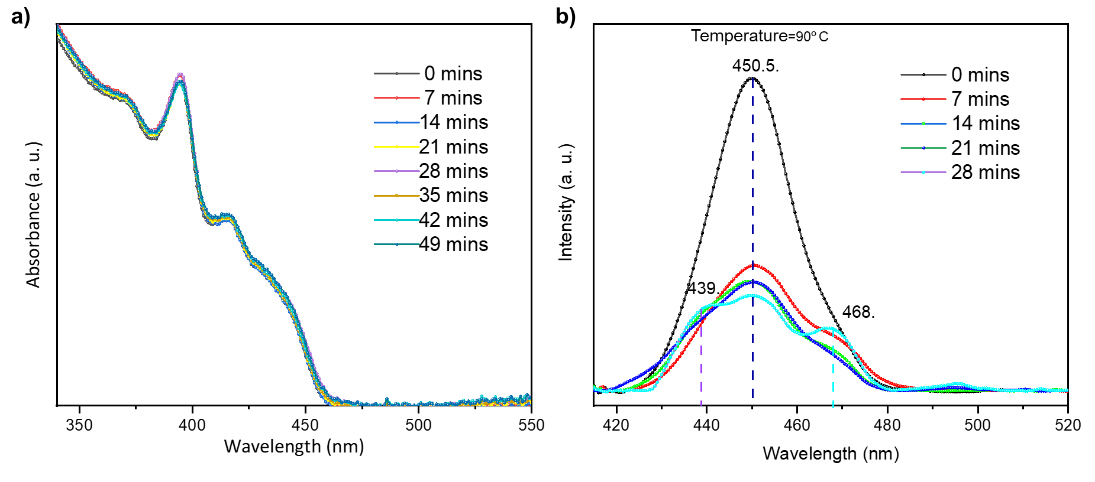Figure 3.5: Thermal stability studies on 100% PEACl composition thin films a) UV-Vis absorption spectra and b) PL emission spectra of the thin films by heating the film at 90º C for various time periods.
In this work, we have synthesized RP-based Q2DPes (PEA)₂Cs_{n-1}Pb_{n}(Br_{x}Cl_{x-1})_{3n+1} for the pure deep blue emission. We strategically introduced PEACl into CsPbBr_{1.8}Cl_{1.2} perovskite precursor, which is having highest possible Cl¯ concentration. Then we conducted optical, structural, and morphological characterizations for those Q2DPe thin films. Here, PEA⁺ and Cl¯ ions of PEACl played multiple roles. While PEA⁺ cations passivated the surface to enhance the PLQY and also induced 2D nature to the perovskite by intercalating the 3D inorganic framework, whereas Cl¯ anions increased the overall Cl¯ concentration in the precursor which further replaced the Br͞ from X¯ sites of the perovskite lattice that promoted the further bandgap widening, which is desirable for tuning the emission towards the challenging deep blue-emitting region.
3.3 Conclusion
In conclusion, we achieved narrow deep blue emissive Q2DPes wherein, 100% PEACl composition has exhibited the best performance with PL peaking at 450.5 nm with FWHM of ~18 nm and 16.3% PLQY. We also demonstrated the implication on the impact of PEACl concentration on Q2DPe thin film. In addition, the temperature-dependent PL studies revealed phase segregation in the thin film as the result of halide migration (Cl¯/Br¯), but interestingly individual PL emissions from each phase (Cl¯ rich/mixed/ Br¯ rich) was obtained indicating radiative recombination within the domain instead of exciton funnelling to the lowest bandgap domain. We believe that the mechanistic insights on this suppressed exciton funnelling to the lowest bandgap phase provide clues to improve V_{oc} in mixed halide perovskite solar cells. However, further in-depth research is need of the hour to understand the underlying mechanisms through advanced spectroscopic studies and enhance the efficiency and stability of these deep blue emissive Q2DPes for their application in LEDs.

Associated Content
Appendices II: PEACl synthesis method, Q2DPe thin film preparation method, characterization details, PL spectra of 100% PEACl film at 372 nm and 393 nm excitation wavelength (Figure 1), SEM images (Figure 2), and TEM images (Figure 3).
Author Information
Corresponding Author
*Email: murali.banavoth@uohyd.ac.in
Acknowledgment
This work was supported by the School of Chemistry, University of Hyderabad. RRS acknowledges Council of Scientific and Industrial Research (CSIR) for the Senior Research Fellowship (SRF). BM acknowledges the University of Hyderabad for the IoE grant (UoH-IoE-RC2-21-008).
Conflict Of Interest
There are no conflicts to declare.
References
(1) Min, H.; Lee, D. Y.; Kim, J.; Kim, G.; Lee, K. S.; Kim, J.; Paik, M. J.; Kim, Y. K.; Kim, K. S.; Kim, M. G.; Shin, T. J.; Il Seok, S. Perovskite solar cells with atomically coherent interlayers on SnO2 electrodes. Nature 2021, 598, 444-450.
(2) Jeong, J.; Kim, M.; Seo, J.; Lu, H.; Ahlawat, P.; Mishra, A.; Yang, Y.; Hope, M. A.; Eickemeyer, F. T.; Kim, M.; Yoon, Y. J.; Choi, I. W.; Darwich, B. P.; Choi, S. J.; Jo, Y.; Lee, J. H.; Walker, B.; Zakeeruddin, S. M.; Emsley, L.; Rothlisberger, U.; Hagfeldt, A.; Kim, D. S.; Grätzel, M.; Kim, J. Y. Pseudo-halide anion engineering for α-FAPbI3 perovskite solar cells. Nature 2021, 592, 381-385.
(3) Karlsson, M.; Yi, Z.; Reichert, S.; Luo, X.; Lin, W.; Zhang, Z.; Bao, C.; Zhang, R.; Bai, S.; Zheng, G.; Teng, P.; Duan, L.; Lu, Y.; Zheng, K.; Pullerits, T.; Deibel, C.; Xu, W.; Friend, R.; Gao, F. Mixed halide perovskites for spectrally stable and high-efficiency blue light-emitting diodes. Nat. Commun. 2021, 12, 361.
(4) Fakharuddin, A.; Gangishetty, M. K.; Abdi-Jalebi, M.; Chin, S.-H.; bin Mohd Yusoff, A. R.; Congreve, D. N.; Tress, W.; Deschler, F.; Vasilopoulou, M.; Bolink, H. J. Perovskite light-emitting diodes. Nat. Electron. 2022, 5, 203-216.
(5) Nie, R.; Sumukam, R. R.; Reddy, S. H.; Banavoth, M.; Seok, S. I. Lead-free perovskite solar cells enabled by hetero-valent substitutes. Energy Environ. Sci. 2020, 13, 2363-2385.
(6) Park, N.-G. Perovskite solar cells: an emerging photovoltaic technology. Mater. Today 2015, 18, 65-72.
(7) Deschler, F.; Price, M.; Pathak, S.; Klintberg, L. E.; Jarausch, D.-D.; Higler, R.; Hüttner, S.; Leijtens, T.; Stranks, S. D.; Snaith, H. J.; Atatüre, M.; Phillips, R. T.; Friend, R. H. High Photoluminescence Efficiency and Optically Pumped Lasing in Solution-Processed Mixed Halide Perovskite Semiconductors. J. Phys. Chem. Lett. 2014, 5, 1421-1426.
(8) Kim, G.-W.; Petrozza, A. Defect Tolerance and Intolerance in Metal-Halide Perovskites. Adv. Energy Mater. 2020, 10, 2001959.
(9) Stranks Samuel, D.; Eperon Giles, E.; Grancini, G.; Menelaou, C.; Alcocer Marcelo, J. P.; Leijtens, T.; Herz Laura, M.; Petrozza, A.; Snaith Henry, J. Electron-Hole Diffusion Lengths Exceeding 1 Micrometer in an Organometal Trihalide Perovskite Absorber. Science 2013, 342, 341-344.
(10) Tan, Z.-K.; Moghaddam, R. S.; Lai, M. L.; Docampo, P.; Higler, R.; Deschler, F.; Price, M.; Sadhanala, A.; Pazos, L. M.; Credgington, D.; Hanusch, F.; Bein, T.; Snaith, H. J.; Friend, R. H. Bright light-emitting diodes based on organometal halide perovskite. Nat. Nanotechnol. 2014, 9, 687-692.
(11) Xu, W.; Hu, Q.; Bai, S.; Bao, C.; Miao, Y.; Yuan, Z.; Borzda, T.; Barker, A. J.; Tyukalova, E.; Hu, Z.; Kawecki, M.; Wang, H.; Yan, Z.; Liu, X.; Shi, X.; Uvdal, K.; Fahlman, M.; Zhang, W.; Duchamp, M.; Liu, J.-M.; Petrozza, A.; Wang, J.; Liu, L.-M.; Huang, W.; Gao, F. Rational molecular passivation for high-performance perovskite light-emitting diodes. Nat. Photonics 2019, 13, 418-424.
(12) Lin, K.; Xing, J.; Quan, L. N.; de Arquer, F. P. G.; Gong, X.; Lu, J.; Xie, L.; Zhao, W.; Zhang, D.; Yan, C.; Li, W.; Liu, X.; Lu, Y.; Kirman, J.; Sargent, E. H.; Xiong, Q.; Wei, Z. Perovskite light-emitting diodes with external quantum efficiency exceeding 20 per cent. Nature 2018, 562, 245-248.
(13) Liu, X.-K.; Xu, W.; Bai, S.; Jin, Y.; Wang, J.; Friend, R. H.; Gao, F. Metal halide perovskites for light-emitting diodes. Nat. Mater. 2021, 20, 10-21.
(14) Tang, X.; van den Berg, M.; Gu, E.; Horneber, A.; Matt, G. J.; Osvet, A.; Meixner, A. J.; Zhang, D.; Brabec, C. J. Local Observation of Phase Segregation in Mixed-Halide Perovskite. Nano Lett. 2018, 18, 2172-2178.
(15) Vashishtha, P.; Halpert, J. E. Field-Driven Ion Migration and Color Instability in Red-Emitting Mixed Halide Perovskite Nanocrystal Light-Emitting Diodes. Chem. Mater. 2017, 29, 5965-5973.
(16) Ochsenbein, S. T.; Krieg, F.; Shynkarenko, Y.; Rainò, G.; Kovalenko, M. V. Engineering Color-Stable Blue Light-Emitting Diodes with Lead Halide Perovskite Nanocrystals. ACS Appl. Mater. Interfaces 2019, 11, 21655-21660.
(17) Kovalenko Maksym, V.; Protesescu, L.; Bodnarchuk Maryna, I. Properties and potential optoelectronic applications of lead halide perovskite nanocrystals. Science 2017, 358, 745-750.
(18) Dey, A.; Ye, J.; De, A.; Debroye, E.; Ha, S. K.; Bladt, E.; Kshirsagar, A. S.; Wang, Z.; Yin, J.; Wang, Y.; Quan, L. N.; Yan, F.; Gao, M.; Li, X.; Shamsi, J.; Debnath, T.; Cao, M.; Scheel, M. A.; Kumar, S.; Steele, J. A.; Gerhard, M.; Chouhan, L.; Xu, K.; Wu, X.-g.; Li, Y.; Zhang, Y.; Dutta, A.; Han, C.; Vincon, I.; Rogach, A. L.; Nag, A.; Samanta, A.; Korgel, B. A.; Shih, C.-J.; Gamelin, D. R.; Son, D. H.; Zeng, H.; Zhong, H.; Sun, H.; Demir, H. V.; Scheblykin, I. G.; Mora-Seró, I.; Stolarczyk, J. K.; Zhang, J. Z.; Feldmann, J.; Hofkens, J.; Luther, J. M.; Pérez-Prieto, J.; Li, L.; Manna, L.; Bodnarchuk, M. I.; Kovalenko, M. V.; Roeffaers, M. B. J.; Pradhan, N.; Mohammed, O. F.; Bakr, O. M.; Yang, P.; Müller-Buschbaum, P.; Kamat, P. V.; Bao, Q.; Zhang, Q.; Krahne, R.; Galian, R. E.; Stranks, S. D.; Bals, S.; Biju, V.; Tisdale, W. A.; Yan, Y.; Hoye, R. L. Z.; Polavarapu, L. State of the Art and Prospects for Halide Perovskite Nanocrystals. ACS Nano 2021, 15, 10775-10981.
(19) Song, J.; Li, J.; Li, X.; Xu, L.; Dong, Y.; Zeng, H. Quantum Dot Light-Emitting Diodes Based on Inorganic Perovskite Cesium Lead Halides (CsPbX3). Adv. Mater. 2015, 27, 7162-7167.
(20) Hoye, R. L. Z.; Lai, M.-L.; Anaya, M.; Tong, Y.; Gałkowski, K.; Doherty, T.; Li, W.; Huq, T. N.; Mackowski, S.; Polavarapu, L.; Feldmann, J.; MacManus-Driscoll, J. L.; Friend, R. H.; Urban, A. S.; Stranks, S. D. Identifying and Reducing Interfacial Losses to Enhance Color-Pure Electroluminescence in Blue-Emitting Perovskite Nanoplatelet Light-Emitting Diodes. ACS Energy Lett. 2019, 4, 1181-1188.
(21) Yang, D.; Zou, Y.; Li, P.; Liu, Q.; Wu, L.; Hu, H.; Xu, Y.; Sun, B.; Zhang, Q.; Lee, S.-T. Large-scale synthesis of ultrathin cesium lead bromide perovskite nanoplates with precisely tunable dimensions and their application in blue light-emitting diodes. Nano Energy 2018, 47, 235-242.
(22) Peng, S.; Wang, S.; Zhao, D.; Li, X.; Liang, C.; Xia, J.; Zhang, T.; Xing, G.; Tang, Z. Pure Bromide-Based Perovskite Nanoplatelets for Blue Light-Emitting Diodes. Small Methods 2019, 3, 1900196.
(23) Deng, W.; Jin, X.; Lv, Y.; Zhang, X.; Zhang, X.; Jie, J. 2D Ruddlesden–Popper Perovskite Nanoplate Based Deep-Blue Light-Emitting Diodes for Light Communication. Adv. Funct. Mater. 2019, 29, 1903861.
(24) Bohn, B. J.; Tong, Y.; Gramlich, M.; Lai, M. L.; Döblinger, M.; Wang, K.; Hoye, R. L. Z.; Müller-Buschbaum, P.; Stranks, S. D.; Urban, A. S.; Polavarapu, L.; Feldmann, J. Boosting Tunable Blue Luminescence of Halide Perovskite Nanoplatelets through Postsynthetic Surface Trap Repair. Nano Lett. 2018, 18, 5231-5238.
(25) Wu, Y.; Wei, C.; Li, X.; Li, Y.; Qiu, S.; Shen, W.; Cai, B.; Sun, Z.; Yang, D.; Deng, Z.; Zeng, H. In Situ Passivation of PbBr64– Octahedra toward Blue Luminescent CsPbBr3 Nanoplatelets with Near 100% Absolute Quantum Yield. ACS Energy Lett. 2018, 3, 2030-2037.
(26) Stoumpos, C. C.; Cao, D. H.; Clark, D. J.; Young, J.; Rondinelli, J. M.; Jang, J. I.; Hupp, J. T.; Kanatzidis, M. G. Ruddlesden–Popper Hybrid Lead Iodide Perovskite 2D Homologous Semiconductors. Chem. Mater. 2016, 28, 2852-2867.
(27) Kumar, G. S.; Sumukam, R. R.; Murali, B. Quasi-2D perovskite emitters: a boon for efficient blue light-emitting diodes. J. Mater. Chem. C 2020, 8, 14334-14347.
(28) Kataoka, T.; Kondo, T.; Ito, R.; Sasaki, S.; Uchida, K.; Miura, N. Magneto-optical study on the excitonic spectrum of (C6H13NH3)2PbI4. Physica B Condens. Matter 1993, 184, 132-136.
(29) Muljarov, E. A.; Tikhodeev, S. G.; Gippius, N. A.; Ishihara, T. Excitons in self-organized semiconductor/insulator superlattices: PbI-based perovskite compounds. Phys. Rev. B Condens. Matter 1995, 51, 14370-14378.
(30) Ishihara, T.; Takahashi, J.; Goto, T. Exciton state in two-dimensional perovskite semiconductor (C10H21NH3)2PbI4. Solid State Commun. 1989, 69, 933-936.
(31) Shang, Y.; Li, G.; Liu, W.; Ning, Z. Quasi-2D Inorganic CsPbBr3 Perovskite for Efficient and Stable Light-Emitting Diodes. Adv. Funct. Mater. 2018, 28, 1801193.
(32) Li, Z.; Chen, Z.; Yang, Y.; Xue, Q.; Yip, H.-L.; Cao, Y. Modulation of recombination zone position for quasi-two-dimensional blue perovskite light-emitting diodes with efficiency exceeding 5%. Nat. Commun. 2019, 10, 1027.
(33) Chen, P.; Meng, Y.; Ahmadi, M.; Peng, Q.; Gao, C.; Xu, L.; Shao, M.; Xiong, Z.; Hu, B. Charge-transfer versus energy-transfer in quasi-2D perovskite light-emitting diodes. Nano Energy 2018, 50, 615-622.
(34) Ono, L. K.; Juarez-Perez, E. J.; Qi, Y. Progress on Perovskite Materials and Solar Cells with Mixed Cations and Halide Anions. ACS Appl. Mater. Interfaces 2017, 9, 30197-30246.
(35) Zhou, Y.; Zhou, Z.; Chen, M.; Zong, Y.; Huang, J.; Pang, S.; Padture, N. P. Doping and alloying for improved perovskite solar cells. J. Mater. Chem. A 2016, 4, 17623-17635.
(36) Yin, W.-J.; Yang, J.-H.; Kang, J.; Yan, Y.; Wei, S.-H. Halide perovskite materials for solar cells: a theoretical review. J. Mater. Chem. A 2015, 3, 8926-8942.
(37) Chen, Q.; De Marco, N.; Yang, Y.; Song, T.-B.; Chen, C.-C.; Zhao, H.; Hong, Z.; Zhou, H.; Yang, Y. Under the spotlight: The organic–inorganic hybrid halide perovskite for optoelectronic applications. Nano Today 2015, 10, 355-396.
(38) Luo, S.; Daoud, W. A. Recent progress in organic–inorganic halide perovskite solar cells: mechanisms and material design. J. Mater. Chem. A 2015, 3, 8992-9010.
(39) Kazim, S.; Nazeeruddin, M. K.; Grätzel, M.; Ahmad, S. Perovskite as Light Harvester: A Game Changer in Photovoltaics.Angew. Chem. Int. Ed. 2014, 53, 2812-2824.
(40) Wang, S.; Wang, A.; Hao, F. Toward stable lead halide perovskite solar cells: A knob on the A/X sites components. iScience 2021, 25, 103599-103599.
(41) Tao, S.; Schmidt, I.; Brocks, G.; Jiang, J.; Tranca, I.; Meerholz, K.; Olthof, S. Absolute energy level positions in tin- and lead-based halide perovskites. Nat. Commun. 2019, 10, 2560.
(42) Li, C.; Wei, J.; Sato, M.; Koike, H.; Xie, Z.-Z.; Li, Y.-Q.; Kanai, K.; Kera, S.; Ueno, N.; Tang, J.-X. Halide-Substituted Electronic Properties of Organometal Halide Perovskite Films: Direct and Inverse Photoemission Studies. ACS Appl. Mater. Interfaces 2016, 8, 11526-11531.
(43) Philippe, B.; Jacobsson, T. J.; Correa-Baena, J.-P.; Jena, N. K.; Banerjee, A.; Chakraborty, S.; Cappel, U. B.; Ahuja, R.; Hagfeldt, A.; Odelius, M.; Rensmo, H. Valence Level Character in a Mixed Perovskite Material and Determination of the Valence Band Maximum from Photoelectron Spectroscopy: Variation with Photon Energy. J. Phys. Chem. C 2017, 121, 26655-26666.
(44) Sumukam, R. R.; Sahu, P.; Savu, R. N.; Khanam, S. J.; Alsulami, Q. A.; Banavoth, M. Halide Ions Distribution and Charge Dynamics in Mixed-Halide Perovskites. Phys. Status Solidi Rapid Res. Lett. 2022, 16, 2100576.
(45) Wang, Q.; Wang, X.; Yang, Z.; Zhou, N.; Deng, Y.; Zhao, J.; Xiao, X.; Rudd, P.; Moran, A.; Yan, Y.; Huang, J. Efficient sky-blue perovskite light-emitting diodes via photoluminescence enhancement. Nat. Commun. 2019, 10, 5633.
(46) Qin, C.; Matsushima, T.; Potscavage, W. J.; Sandanayaka, A. S. D.; Leyden, M. R.; Bencheikh, F.; Goushi, K.; Mathevet, F.; Heinrich, B.; Yumoto, G.; Kanemitsu, Y.; Adachi, C. Triplet management for efficient perovskite light-emitting diodes. Nat. Photon. 2020, 14, 70-75.
(47) Wang, F.; Wang, Z.; Sun, W.; Wang, Z.; Bai, Y.; Hayat, T.; Alsaedi, A.; Tan, Z. a. High Performance Quasi-2D Perovskite Sky-Blue Light-Emitting Diodes Using a Dual-Ligand Strategy. Small 2020, 16, 2002940.
(48) Xiao, Z.; Kerner, R. A.; Zhao, L.; Tran, N. L.; Lee, K. M.; Koh, T.-W.; Scholes, G. D.; Rand, B. P. Efficient perovskite light-emitting diodes featuring nanometre-sized crystallites. Nat. Photonics 2017, 11, 108-115.
(49) Knight, A. J.; Herz, L. M. Preventing phase segregation in mixed-halide perovskites: a perspective. Energy Environ. Sci. 2020, 13, 2024-2046.

